**Sustainable Impact of the Ardnacrusha Hydroelectric for the Shannon Region**

**🚀 Challenge Theme**

**“Balancing energy, environment & innovation in the Shannon basin”**

**📖 Introduction / Context**

The Ardnacrusha Hydroelectric Station, built in 1929, was once the largest engineering project in the world and remains a key part of Ireland’s renewable energy. Today, the Shannon region is positioning itself as a hub for research, advanced manufacturing, and green innovation.

But this raises key questions:

* How can Ardnacrusha continue to power industry and homes sustainably?
* How can we protect biodiversity, particularly salmon migration?
* How can infrastructure upgrades, digital tools, and space technology make it smarter, cleaner, and more efficient?

**Imagery to add here:**

A historic photo of Ardnacrusha in the 1930s, paired with a modern aerial shot.

A satellite image of the Shannon River basin (from Copernicus/Sentinel).

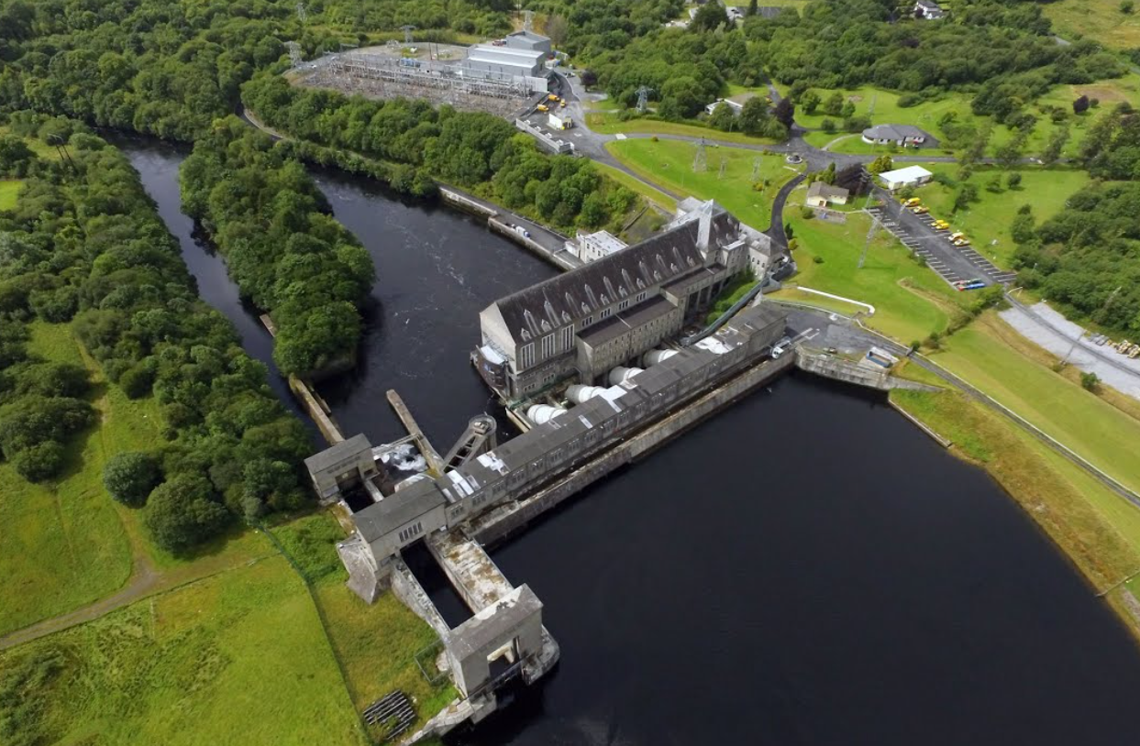

**❓ Challenge Statement**

How can we reimagine Ardnacrusha’s sustainable impact so that it:

* Delivers reliable, clean energy to industry while preserving the Shannon ecosystem,
* Modernises infrastructure for efficiency and ecological compatibility,
* Supports regional innovation, research, and manufacturing,
* Applies space-enabled tools (satellite, IoT, digital twins),
* Yields quantifiable social, economic, and environmental benefits for the Shannon region?

**🎯 Missions (Team Tasks)**

| **Mission** | **Focus** |
| --- | --- |
| **1. Optimize Energy & Infrastructure** | Propose upgrades to turbines, control systems, or hydraulic flow that boost output or efficiency by 3–10%. |
| **2. Ecosystem Protection & Restoration** | Design fish passage systems, flow management, or habitat redesigns to raise salmon survival from < 50% to 70–80%. |
| **3. Monitoring via Space & Sensors** | Use satellite imagery, drones, sensor networks, or digital twins to monitor river health, infrastructure stress, or fish migration. |
| **4. Regional Innovation Ecosystem** | Define pathways to attract startups, research labs, or manufacturing powered by Ardnacrusha’s clean energy. |
| **5. Impact Quantification & Transferability** | Model energy gains, biodiversity benefits, job creation, CO₂ reductions — and propose how it could apply to other rivers worldwide. |

**Imagery to add here:**

* Diagram of a fish ladder or bypass system.
* Example dashboard/mockup for environmental monitoring.

**📊 Challenge Metrics (Inspiration)**

* +5% efficiency = enough extra electricity for ~10,000 households
* Salmon survival raised from < 50% → 70–80%
* Industrial CO₂ reduction of 10–15% through green energy supply
* Monitoring costs cut by ~40% using satellites & IoT
* New green jobs, startups, and education opportunities in Shannon

**🤝 Resources & Collaborators**

* **Data:** Hydrology of the Shannon, salmon migration/fish kill records
* **Tools:** Copernicus & Sentinel satellite data, IoT kits, drones
* **Partners:** ESB, Siemens, Irish Waterways, Universities, Research Institutes
* **Frameworks:** EU Green Deal, Irish renewable & biodiversity policies

**🏆 Evaluation Criteria**

1. Feasibility & Clarity
2. Relevance to energy–environment balance
3. Innovation & Creativity
4. Quantifiable Impact
5. Transferability to other hydro contexts
6. Effective use of tech & partnerships

**🌍 Why This Matters**

Solutions from this challenge could:

* Provide **energy resilience** for local homes & industries
* Protect and restore **river ecosystems & salmon populations**
* Spur **new green industries, startups, and jobs** in Shannon
* Position Shannon as a **sustainability innovation hub**
* Create **models for sustainable hydropower** applicable worldwide

**Imagery to add here:**

* Infographic showing “triple win”: Energy ⚡ + Ecosystem 🐟 + Economy 💼
* Map of Shannon innovation assets (universities, clusters, waterways).